Findings from a global survey of patient experience: Insights from patients from Portugal

Overview

Improving patients’ experience of their treatment and care is an important issue for the Global Lung Cancer Coalition (GLCC) and its members. There is, however, little data comparing patient experience between countries.

The GLCC therefore set out gain insights into patient experience, working with its network of patient advocacy groups to share a multi-national online survey with patients around the world.

This document sets out the findings for Portugal, including comparisons with the other countries that took part.

This was the first time the GLCC had conducted a survey in this way. We have included lessons we have learned from running the survey and suggestions for areas that could be explored in future surveys, whether global or national.

We are keen for the findings to be useful to GLCC members in their campaigning and advocacy. However, if you wish to use the data externally, please let us know. The GLCC is planning to submit abstracts to the IASLC World Conference on Lung Cancer and the World Cancer Congress so it is important that we do not publish anything that could mean these abstracts are not accepted.

Should you wish to use the data externally, please contact glcc@roycastle.org and we will be happy to support you.

Contents
Overview 1
Methodology 3
DEMOGRAPHICS: WHO PARTICIPATED? 4
Number and gender of respondents 4
Age at diagnosis 5
Type of lung cancer 6
Year of diagnosis 8
INTERVENTIONS: WHAT TESTING, TREATMENT AND SUPPORT HAVE PEOPLE HAD? 9
Biomarker testing 9
Treatment 10
Support received 13
PATIENT EXPERIENCE 16
Feeling involved in decisions about their treatment and care 16
Being treated with dignity and respect 17
How do people diagnosed with lung cancer describe themselves? 18
More information 21

Methodology

The GLCC established a multi-national steering group including patients, healthcare professionals and advocates to develop the survey questions. The survey was translated into 13 languages so patients could complete it in their native language. It was distributed by members and promoted through social media.

The survey was sent out in 17 different countries: Argentina, Australia, Brazil, Bulgaria, Canada, Czech Republic, Denmark, Ireland, Mexico, the Netherlands, Peru, Portugal, Spain, Sweden, Turkey, the UK, the USA. More than 900 patients completed the survey in total.

The questions for the survey were split into three main themes:

- Demographics – used for identifying patient populations by gender, age at diagnosis, type of lung cancer, and time since diagnosis
- Interventions – to understand what testing and treatments people have had in their cancer journey
- Experiences – to assess how involved patients feel in decision-making about care, whether they felt treated with dignity and respect, and how they describe themselves in the light of their experience (for example as a patient
or a survivor)

In the figures below, the countries are ranked in order of total number of responses from each country. The rows for the Czech Republic, Peru, Argentina and Turkey are shaded in grey, indicating that these countries had fewer than ten responses. The GLCC felt it important to include the responses from patients in these countries, but they are not highlighted when identifying countries with highest or lowest percentage responses.

DEMOGRAPHICS: WHO PARTICIPATED?

Number and gender of respondents

Globally, 907 patients and carers completed the survey. 16 people from Portugal responded (please see Figure 1). Globally, the majority (73%) of the respondents were women. Portugal was the only country that had an even split between men and women respondents.

Figure 1: Number and percentage of respondents, by country

Women Men Prefer not to say Other
Country | Number Percentage Number Percentage | Number | Percentage | Number | Percentage

UK | 117 | 74% | 40 | 25% | 0 | 0% | 1 | 1%
The Netherlands | 113 | 74% | 39 | 26% | 0 | 0% | 0 | 0%
Brazil | 99 | 72% | 38 | 27% | 1 | 1% | 0 | 0%
Sweden | 87 | 95% | 5 | 5% | 0 | 0% | 0 | 0%
Spain | 40 | 58% | 29 | 42% | 0 | 0% | 0 | 0%
USA | 40 | 75% | 13 | 25% | 0 | 0% | 0 | 0%
Canada | 40 | 76% | 11 | 22% | 1 | 2% | 0 | 0%
Ireland | 31 | 74% | 10 | 24% | 1 | 2% | 0 | 0%
Mexico | 24 | 59% | 17 | 41% | 0 | 0% | 0 | 0%
Australia | 29 | 74% | 10 | 26% | 0 | 0% | 0 | 0%
Denmark | 17 | 71% | 7 | 29% | 0 | 0% | 0 | 0%
Portugal | 8 | 50% | 8 | 50% | 0 | 0% | 0 | 0%
Bulgaria | 12 | 80% | 3 | 20% | 0 | 0% | 0 | 0%
Czech Republic | 4 | 67% | 2 | 33% | 0 | 0% | 0 | 0%
Peru | 4 | 80% | 0 | 0% | 1 | 20% | 0 | 0%
Argentina | 2 | 40% | 3 | 60% | 0 | 0% | 0 | 0%
Turkey | 0 | 0% | 1 | 100% | 0 | 0% | 0 | 0%

Age at diagnosis

Respondents were asked how old they were when they received their diagnosis (Figure 2). Globally, people were most likely to say they were diagnosed between the ages of 55-59 (20% of respondents) followed by ages 50-54 (16% of respondents).

In Portugal, the most common age at time of diagnosis was around the same, with half of respondents being diagnosed between 50 – 59, followed by 19% of respondents being diagnosed between 65 – 69. While Portugal has a higher proportion of respondents diagnosed between 0 – 14 than other countries, this only represents one respondent. All 16 respondents from Portugal answered this question.

Figure 2: Age profile of respondents
How old were you when you were diagnosed?
30

25

20

15

10

5

0
0 - 14
15 - 39
40 - 44
45 - 49 50 - 54 55 - 59
60 - 64
65 - 69
70+
I don’t
know
Portugal Global
Percentage of overall responses

Type of lung cancer

Respondents were asked which type of lung cancer they had (Figure 3). The survey included a list of eight different
types of lung cancer as well as an ‘I don’t know’ option.

Non-small cell lung cancer is the most common form of cancer, accounting for 80-85% of all lung cancers.¹ Respondents to the GLCC global survey broadly fit this, with 75% of respondents stating they had non-small cell lung cancer. In Portugal, a higher proportion of respondents (93%) stated they had non-small cell lung cancer. 14 out of 16 respondents from Portugal answered this question.

Figure 3: Type of lung cancer among respondents
What type of lung cancer were you diagnosed with?
100
90
80
70
60
50
40
30
20
10
0
Small cell lung
cancer
Non small cell lung
cancer
Pancoast tumour
Mesothelioma
I don't know
Portugal Global
Percentage of overall responses

The survey indicated that some patients do not know which type of lung cancer they had or have. Globally, 13% of respondents did not know what lung cancer they had or have. One respondent (7%) from Portugal did not know what type of lung cancer they had; this was the third lowest percentage (Figure 4).

The type of lung cancer a patient has will affect the treatment options that are available to them. It is essential that patients know which type of cancer they have to be able to understand their treatment choices, and to feel empowered and fully involved in decisions about their care.

¹ American Cancer Society, What is lung cancer? Types of lung cancer. Available at: https://www.cancer.org/cancer/lung- cancer/about/what-is.html

Figure 4: Percentage of respondents who did not know what type of lung cancer they have
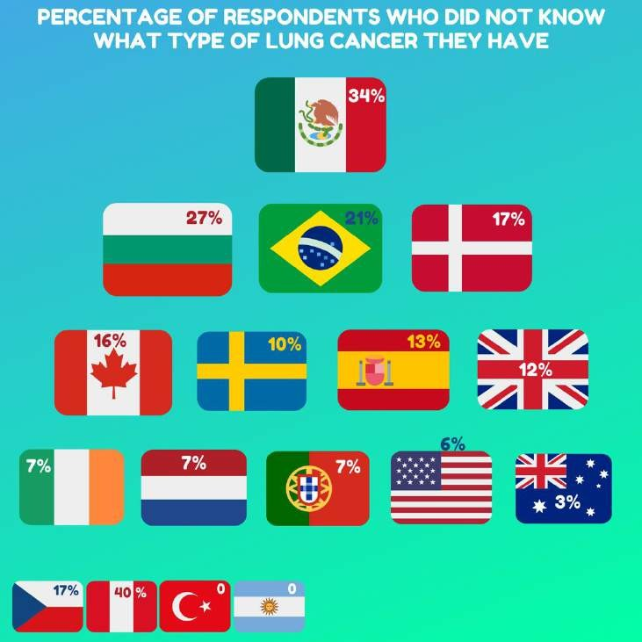

Further survey work could be conducted to determine:

- Whether the figure of 7% of respondents who do not know what type of lung cancer they have reflects the experience of the wider lung cancer patient population in Portugal (given that it was just one patient)
- If there is a correlation between patients’ knowledge of their cancer type and other responses, such as how involved they feel about decisions about their care

Year of diagnosis

Respondents were asked in which year they were diagnosed. Knowing how recently a patient was diagnosed may help to understand differences in their diagnostic journey (for example, whether they received a biomarker test) or treatment (since treatments change over time). All 16 respondents from Portugal answered this question.

Globally, around a third of respondents (30%) were diagnosed in 2019 (Figure 5). This proportion was higher for respondents from Portugal, with 38% being diagnosed in 2019.

Portugal had a higher proportion of respondents diagnosed in 2016 and 2015 than the global average (19% and 13% versus 11% and 6% respectively). This is also the case for 2010 and before 2009, although this equates to only one respondent for each year.

44% of Portuguese respondents were diagnosed more than three years ago – 10% more as the global average, which was 34%.

Figure 5: Year of diagnosis amongst respondents
In what year were you diagnosed?
40

35

30

25

20

15

10

5

0
2019 2018 2017 2016 2015 2014 2013 2012 2011 2010 2009 Before I don’t
2009 know

Portugal Global
Percentage of overall responses

INTERVENTIONS: WHAT TESTING, TREATMENT AND SUPPORT HAVE PEOPLE HAD?

Biomarker testing

Research has increased our understanding of lung cancer and we now know that no two lung cancers are the same. The molecular characteristics of a tumour – its biomarkers – can be used to help physicians decide which treatment may work best for individual patients.

Increasing research has gone into identifying biomarkers and developing new targeted treatments over the past decade. We therefore gave a short explanation of what a biomarker is and asked patients if they knew whether or not they had received a biomarker test. All 16 respondents from Portugal answered this question.

Portugal had one of the highest proportion of respondents who said they had received a biomarker test (63%), and scored relatively low for respondents who said they hadn’t received one (19%) compared to the other countries. 3 patients (19%) from Portugal were not sure if they’d had a biomarker test (Figure 6).

Figure 6: Biomarker testing amongst respondents

Yes |  |  |  | No |  | I don't know
Country | Number | Percentage | Number | Percentage |  | Number | Percentage

UK | 94 | 60% | 29 | 18% | 34 | 22%
The Netherlands | 99 | 65% | 34 | 22% | 19 | 13%
Brazil | 75 | 55% | 42 | 31% | 19 | 14%
Sweden | 55 | 60% | 13 | 14% | 24 | 26%
Spain | 43 | 62% | 15 | 22% | 11 | 16%
USA | 35 | 66% | 6 | 11% | 12 | 23%
Canada | 26 | 53% | 14 | 29% | 9 | 18%
Ireland | 19 | 45% | 11 | 26% | 12 | 29%
Mexico | 16 | 39% | 6 | 15% | 19 | 46%
Australia | 25 | 64% | 6 | 15% | 8 | 21%
Denmark | 14 | 58% | 7 | 29% | 3 | 13%
Portugal 10 63% 3 19% 3 19%

Bulgaria 10 67% 3 20% 2 13%
Czech Republic | 3 | 50% | 1 | 17% | 2 | 33%
Peru | 3 | 60% | 0 | 0% | 2 | 40%
Argentina | 3 | 60% | 0 | 0% | 2 | 40%
Turkey | 0 | 0% | 1 | 100% | 0 | 0%

A further analysis was undertaken to look at whether the proportion of respondents who said they had a biomarker test was higher among those diagnosed more recently. There was no clear correlation, but the sample size was relatively small. National audits may shed more light on the uptake of biomarker testing over time.

Treatment
With a growing understanding of lung cancer, treatment options are increasing. We gave patients a list of treatments and asked them to select all those they had received.

The findings are set out in the Figure 7 below and continued overleaf. Please note that the percentage totals are based on the number of respondents from each country, rather than the total number of global responses.

Comparison with national datasets would be needed to understand whether the treatment options chosen by patients in the survey aligns with that of the wider lung cancer patient population. However, our survey showed the following:

- Surgery: Portugal had the highest proportion of respondents who said they’d had surgery (56%). Surgery is still the best curative option for patients with early stage lung cancer (stages 1 and II) so identifying a larger proportion of patients at an early stage, when surgery is an option for them, should be a priority for all countries.
- Radiotherapy: A quarter of respondents from Portugal (25%) had received radiotherapy, compared to Australia with the highest proportion (67%) and Bulgaria with the lowest (13%)
- Chemotherapy: Portugal also had the highest proportion of respondents who had received chemotherapy (81%) compared to Canada with the lowest (40%)
- Immunotherapy: A quarter of respondents from Portugal (25%) had received immunotherapy, compared to the highest – the USA (47%) and Ireland and Mexico with the lowest (13%)
- Targeted therapies: No respondents from Portugal indicated they had received targeted therapies, compared to Mexico with the highest proportion (55%)
- Symptom management: Portugal had 19% of respondents who indicated they had received treatment to help with symptom management compared to the USA who had the highest proportion with nearly half (49%) saying this was the case. Just one person (7%) from Bulgaria said they’d received this type of support
- No treatment: No respondents from Portugal said they had received no treatment at all. A small number of patients (single figures) in most countries had not received any treatment, although it is not clear if this is because they were waiting to start treatment, if they had refused treatment, or been diagnosed at a stage when active treatment was no longer a possibility

Figure 7: Types of treatment respondents received (continues on the next page)

Surgery Radiotherapy Chemotherapy Immunotherapy
Country | Number | Percentage | Number | Percentage | Number | Percentage | Number | Percentage

The UK | 70 | 45% | 54 | 35% | 87 | 56% | 30 | 19%
The Netherlands | 50 | 33% | 76 | 50% | 80 | 53% | 40 | 26%
Brazil | 41 | 30% | 48 | 35% | 90 | 66% | 37 | 27%
Sweden | 34 | 37% | 35 | 38% | 61 | 67% | 31 | 34%
Spain | 25 | 37% | 36 | 54% | 49 | 73% | 27 | 40%
USA | 17 | 32% | 25 | 47% | 40 | 75% | 25 | 47%
Canada | 19 | 40% | 18 | 38% | 19 | 40% | 11 | 23%
Ireland | 11 | 28% | 15 | 38% | 23 | 59% | 5 | 13%
Mexico | 9 | 23% | 9 | 23% | 25 | 63% | 5 | 13%
Australia | 15 | 38% | 26 | 67% | 21 | 54% | 9 | 23%
Denmark | 8 | 33% | 9 | 38% | 19 | 79% | 7 | 29%
Portugal | 9 | 56% | 4 25% 13 |  |  | 81% | 4 | 25%
Bulgaria | 6 | 40% | 2 | 13% | 11 | 73% | 4 | 27%
Czech Republic | 1 | 17% | 2 | 33% | 4 | 67% | 0 | 0%
Peru | 2 | 40% | 1 | 20% | 4 | 80% | 0 | 0%
Argentina | 3 | 60% | 3 | 60% | 3 | 60% | 2 | 40%
Turkey | 0 | 0% | 1 | 100% | 1 | 100% | 0 | 0%

I have not received any
treatment
Symptom management
Targeted therapies

Country | Number | Percentage | Number | Percentage | Number | Percentage
The UK | 52 | 33% | 37 | 24% | 2 | 1%
The Netherlands | 54 | 36% | 52 | 34% | 3 | 2%
Brazil | 25 | 18% | 41 | 30% | 8 | 6%
Sweden | 25 | 27% | 42 | 46% | 3 | 3%
Spain | 12 | 18% | 15 | 22% | 1 | 1%
USA | 8 | 15% | 26 | 49% | 0 | 0%
Canada | 13 | 27% | 14 | 29% | 3 | 6%
Ireland | 10 | 26% | 11 | 28% | 5 | 13%
Mexico | 22 | 55% | 14 | 35% | 0 | 0%
Australia | 17 | 44% | 15 | 38% | 0 | 0%
Denmark | 1 | 4% | 10 | 42% | 0 | 0%
Portugal | 0 | 0% | 3 | 19% | 0 | 0%
Bulgaria | 1 | 7% | 1 | 7% | 2 | 13%
Czech Republic | 0 | 0% | 1 | 17% | 1 | 17%
Peru | 0 | 0% | 0 | 0% | 0 | 0%
Argentina | 0 | 0% | 1 | 20% | 0 | 0%
Turkey | 0 | 0% | 0 | 0% | 0 | 0%

Support received
Being diagnosed with lung cancer has a huge impact on the way patients live their lives. Patients can benefit from a range of other types of support, beyond treatment itself. This may include counselling or support with mental health, dietary and financial advice, or return to work advice for those of working age who are fit enough after treatment.

Figure 8 (continued on next page) sets out the proportions of respondents receiving these additional types of support. 12 patients from Portugal answered this question. Again, comparison with national datasets and more detailed understanding of the healthcare systems would be needed to understand whether the additional support received by patients in this survey aligns with that of the wider lung cancer patient population. Our survey showed variations in the proportions of patients receiving different kinds of support as follows:

- Psychosocial support / counselling: One third of respondents (33%) from Portugal said they had received this kind of support, compared to 59% of respondents from Spain (the highest proportion) and 23% of respondents from Canada (the lowest proportion)
- Physical therapy / pulmonary rehabilitation: Half the respondents (50%) from Portugal said they had received this, the highest proportion globally
- Occupational therapy: Two thirds (67%) of respondents from Portugal said they had received this, the highest proportion globally
- Dietary advice: A quarter of respondents from Portugal (25%) received dietary advice, compared to 50% of respondents from Bulgaria (highest proportion) and no respondents from Denmark
- Lifestyle advice: No respondents Portugal said they received lifestyle advice
- Financial advice: No respondents from Portugal said they received financial advice, compared to the UK where nearly a third (29%) of respondents received this
- Return to work advice: Just two patients (4%) said they received advice on going back to work. This compares to one in ten respondents (12%) from the UK. No-one from Denmark, Mexico, Portugal or Sweden said they received this kind of support

Figure 8: Types of support respondents received (continued on the next page)

Psychosocial support / Physical therapy / pulmonary Occupational therapy Dietary advice counselling rehabilitation
Country | Number | Percentage | Number | Percentage | Number | Percentage | Number | Percentage

The UK | 40 | 39% | 21 | 21% | 15 | 15% | 33 | 32%
The Netherlands | 56 | 49% | 55 | 48% | 35 | 30% | 7 | 6%
Brazil | 67 | 57% | 43 | 36% | 55 | 47% | 24 | 20%
Sweden | 33 | 54% | 17 | 28% | 20 | 33% | 4 | 7%
Spain | 26 | 59% | 11 | 25% | 0 | 0% | 8 | 18%
USA | 20 | 38% | 13 | 25% | 1 | 2% | 17 | 32%
Canada | 7 | 23% | 6 | 19% | 4 | 13% | 7 | 23%
Ireland | 7 | 24% | 7 | 24% | 2 | 7% | 14 | 48%
Mexico | 9 | 24% | 17 | 46% | 0 | 0% | 13 | 35%
Australia | 15 | 47% | 11 | 34% | 15 | 47% | 6 | 19%
Denmark | 5 | 33% | 5 | 33% | 7 | 47% | 0 | 0%

Portugal 4 33% 6

Bulgaria 4 29% 2
50% 8
14% 5
67%
36%
3 25%
7 50%

Czech Republic | 0 | 0% | 1 | 33% | 2 | 67% | 0 | 0%
Peru | 3 | 75% | 1 | 25% | 0 | 0% | 4 | 100%
Argentina | 3 | 60% | 1 | 20% | 0 | 0% | 1 | 20%
Turkey | 1 | 100% | 0 | 0% | 1 | 100% | 0 | 0%

Advice on going back to work
Financial advice
Lifestyle advice

Country | Number | Percentage | Number | Percentage | Number | Percentage
The UK | 14 | 14% | 30 | 29% | 12 | 12%
The Netherlands | 7 | 6% | 2 | 2% | 8 | 7%
Brazil | 1 | 1% | 4 | 3% | 1 | 1%
Sweden | 2 | 3% | 0 | 0% | 0 | 0%
Spain | 8 | 18% | 1 | 2% | 2 | 5%
USA | 16 | 30% | 8 | 15% | 2 | 4%
Canada | 8 | 26% | 6 | 19% | 3 | 10%
Ireland | 4 | 14% | 0 | 0% | 3 | 10%
Mexico | 4 | 11% | 2 | 5% | 0 | 0%
Australia | 4 | 13% | 1 | 3% | 2 | 6%
Denmark | 1 | 7% | 0 | 0% | 0 | 0%
Portugal | 0 | 0% | 0 | 0% | 0 | 0%
Bulgaria | 0 | 0% | 1 | 7% | 1 | 7%
Czech Republic | 0 | 0% | 0 | 0% | 0 | 0%
Peru | 1 | 25% | 0 | 0% | 0 | 0%
Argentina | 0 | 0% | 0 | 0% | 0 | 0%
Turkey | 0 | 0% | 0 | 0% | 0 | 0%

Further work could be undertaken to explore:

- Which services were offered to patients, as well as whether patients chose to take them up. Not every patient may need every type of support. But patients having choices and being able to access different support when they need it can give an indication of whether the system is providing holistic care
- How useful patients found the services they received
- Who provided the support, for example a hospital, insurer, charity or patient support or advocacy group
- What other types of support patients would have liked to have been offered

PATIENT EXPERIENCE

Feeling involved in decisions about their treatment and care

The GLCC believes that every patient has the right to be fully informed of, and involved in, decisions about their treatment and care. This right is enshrined in the GLCC’s Patient Charter. The survey findings demonstrate variations between countries in the extent to which patients feel sufficiently involved in making decisions about their treatment and care.

Only one respondent from Portugal skipped this question, meaning there were 15 responses. Portugal was the only country to have no respondents selecting that they didn’t feel involved with the decisions about their treatment.
While the proportion of respondents answering ‘yes’ was higher in the USA (92%), in Portugal those respondents
who did not answer ‘yes’ said that they didn’t want to be involved or had a caregiver involved.

Figure 9: Number and proportion of patients feeling involved in decisions on their treatment and care

No, but I didn’t want to No, but my caregiver
Yes No be involved was involved
Country | Number | Percentage | Number | Percentage | Number | Percentage | Number | Percentage

UK | 131 | 84% | 23 | 15% | 2 | 1% | 0 | 0%
The Netherlands | 128 | 86% | 17 | 11% | 2 | 1% | 2 | 1%
Brazil | 88 | 66% | 26 | 20% | 5 | 4% | 14 | 11%
Sweden | 47 | 54% | 30 | 34% | 5 | 6% | 5 | 6%
Spain | 44 | 65% | 16 | 24% | 4 | 6% | 4 | 6%
USA | 48 | 92% | 3 | 6% | 0 | 0% | 1 | 2%
Canada | 38 | 79% | 7 | 15% | 1 | 2% | 2 | 4%
Ireland | 20 | 54% | 13 | 35% | 1 | 3% | 3 | 8%
Mexico | 24 | 59% | 2 | 5% | 1 | 2% | 14 | 34%
Australia | 27 | 71% | 7 | 18% | 2 | 5% | 2 | 5%
Denmark | 17 | 74% | 3 | 13% | 3 | 13% | 0 | 0%
Portugal | 12 | 80% | 0 | 0% | 2 | 13% | 1 | 7%
Bulgaria | 8 | 53% | 4 | 27% | 0 | 0% | 3 | 20%
Czech Republic | 4 | 67% | 0 | 0% | 0 | 0% | 2 | 33%
Peru | 3 | 60% | 1 | 20% | 1 | 20% | 0 | 0%
Argentina | 4 | 80% | 1 | 20% | 0 | 0% | 0 | 0%
Turkey | 1 | 100% | 0 | 0% | 0 | 0% | 0 | 0%

Future studies or surveys could explore:

  - Whether this figure reflects the experience of the wider lung cancer patient population in Portugal (given the relatively small sample size)
  - Why Portuguese patients feel this way compared to patients from other countries, and what can be learned from approaches to shared decision-making in Portugal

Being treated with dignity and respect

Lung cancer patients can often face stigma due to lung cancer’s association with smoking, although a significant proportion of lung cancers are in non-smokers. The GLCC’s Patient Charter asserts the right for every patient to be treated with dignity and respect. No matter the cause of their disease, every patient should be treated respectfully.

The GLCC’s survey asked whether patients felt treated with dignity and respect by the team providing their treatment. Respondents were given a choice of whether they ‘always’, ‘mostly’, ‘sometimes’ or ‘never’ felt treated with dignity and respect.

All 16 respondents from Portugal answered this question. Portugal was the only country globally that had 100% of respondents stating they always felt treated with dignity and respect. While this is only 16 people, it is pleasing to hear so many positive responses (Figure 10):

Figure 10: Number and proportion of patients feeling treated with dignity and respect by their treatment team

Always Mostly Sometimes Never
Country | Number | Percentage | Number | Percentage | Number | Percentage | Number | Percentage

UK | 70 | 65% | 29 | 23% | 14 | 11% | 2 | 1%
The Netherlands | 105 | 70% | 34 | 23% | 8 | 5% | 2 | 1%
Brazil | 100 | 76% | 22 | 17% | 6 | 5% | 3 | 2%
Sweden | 39 | 44% | 36 | 41% | 9 | 11% | 4 | 5%
Spain | 50 | 75% | 13 | 20% | 4 | 6% | 0 | 0%
USA | 31 | 78% | 8 | 20% | 1 | 3% | 0 | 0%
Canada | 30 | 65% | 13 | 28% | 2 | 4% | 1 | 2%
Ireland | 21 | 57% | 11 | 30% | 4 | 11% | 1 | 3%
Mexico | 34 | 83% | 7 | 17% | 0 | 0% | 0 | 0%
Australia | 25 | 66% | 10 | 26% | 3 | 8% | 0 | 0%
Denmark | 13 | 57% | 8 | 35% | 2 | 9% | 0 | 0%
Portugal | 16 | 100% | 0 | 0% | 0 | 0% | 0 | 0%
Bulgaria | 7 | 58% | 0 | 0% | 2 | 17% | 3 | 25%
Czech Republic | 5 | 83% | 1 | 17% | 0 | 0% | 0 | 0%
Peru | 2 | 40% | 2 | 40% | 1 | 20% | 0 | 0%
Argentina | 4 | 80% | 0 | 0% | 1 | 20% | 0 | 0%
Turkey | 1 | 100% | 0 | 0% | 0 | 0% | 0 | 0%

Future studies or surveys could explore:

  - Whether this figure reflects the experience of the wider lung cancer patient population in Portugal (given the relatively small sample size) and what can be learned if so
  - How the proportion of patients answering ‘always’ can be kept high

How do people diagnosed with lung cancer describe themselves?

The GLCC was interested to find out how people diagnosed with lung cancer describe themselves. Often people with
lung cancer are described simply as ‘patients’ but does this tell the full story? For example, people may describe
themselves as a ‘patient’ while they are having treatment, but not if their treatment stops. There is still much to be done to increase survival in lung cancer but, with treatments improving, more people are living for longer after diagnosis. At what point do people start to describe themselves as a ‘survivor’?

Respondents were asked to tick as many of the different descriptions as they felt applied to them. 14 out of 16 respondents from Portugal answered this question. Figure 11 shows the top response in each country while Figure 12 shows all the responses.

The most popular options chosen by respondents from Portugal were ‘overcomer’ and ‘surviving with lung cancer’ with 29% of respondents describing themselves as one or other. 21% of respondent chose ‘living with lung cancer’ or ‘lung cancer survivor’. Just 7% chose ‘patient’

Figure 11: How respondents to the survey described themselves – most popular option in each country
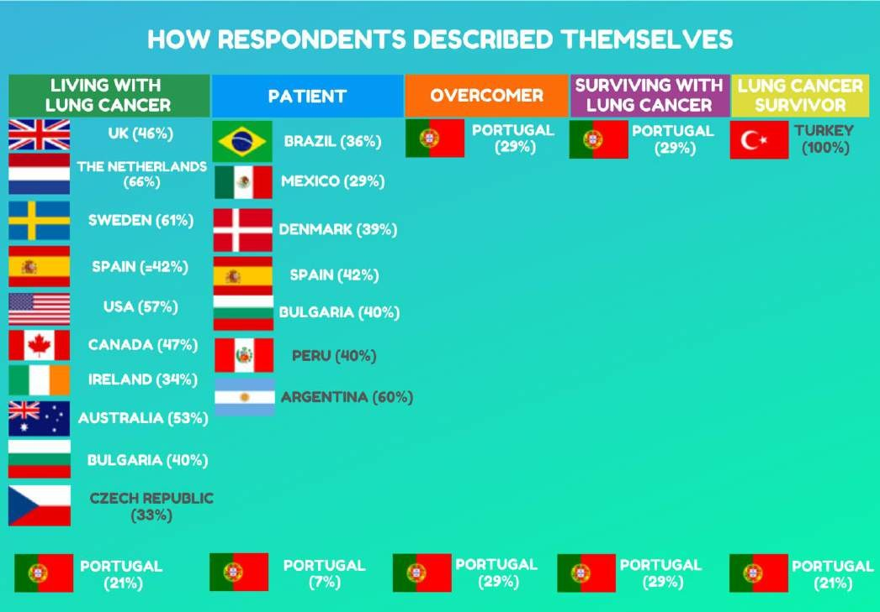
NB: Where country names are in grey it indicates a small number of respondents, where grey shading was used in previous tables and the percentage of respondents from Portugal that chose each category is included at the bottom of the infographic.

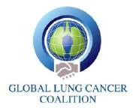

Figure 12: how respondents described themselves – all responses

Living with lung cancer Patient Overcomer Surviving with lung cancer Lung cancer survivor
Country | Number | Percentage | Number | Percentage | Number | Percentage | Number | Percentage | Number | Percentage

UK | 71 | 46% | 47 | 31% | 6 | 4% | 24 | 16% | 43 | 28%
The Netherlands | 97 | 66% | 65 | 44% | 5 | 3% | 17 | 12% | 30 | 20%
Brazil | 45 | 35% | 46 | 36% | 26 | 20% | 31 | 24% | 21 | 16%
Sweden | 54 | 61% | 46 | 52% | 3 | 3% | 12 | 13% | 12 | 13%
Spain | 28 | 42% | 28 | 42% | 1 | 1% | 13 | 19% | 8 | 12%
USA | 30 | 57% | 27 | 51% | 4 | 8% | 12 | 23% | 15 | 28%
Canada | 21 | 47% | 14 | 31% | 2 | 4% | 5 | 11% | 12 | 27%
Ireland | 11 | 34% | 5 | 16% | 2 | 6% | 7 | 22% | 7 | 22%
Mexico | 8 | 20% | 12 | 29% | 1 | 2% | 10 | 24% | 5 | 12%
Australia | 20 | 53% | 17 | 45% | 2 | 5% | 7 | 18% | 13 | 34%
Denmark | 8 | 35% | 9 | 39% | 1 | 4% | 2 | 9% | 7 | 30%
Portugal | 3 | 21% | 1 | 7% | 4 | 29% | 4 | 29% | 3 | 21%
Bulgaria | 6 | 40% | 6 | 40% | 2 | 13% | 4 | 27% | 2 | 13%
Czech Republic | 2 | 33% | 1 | 17% | 1 | 17% | 0 | 0% | 0 | 0%
Peru | 1 | 20% | 2 | 40% | 0 | 0% | 0 | 0% | 1 | 20%
Argentina | 2 | 40% | 3 | 60% | 1 | 20% | 0 | 0% | 0 | 0%
Turkey | 0 | 0% | 0 | 0% | 0 | 0% | 0 | 0% | 1 | 100%

19

There was also an option for people to include their own description. Figure 13 sets out some of the responses from people from Portugal.

Figure 13: How respondents to the survey described themselves – Portugal only
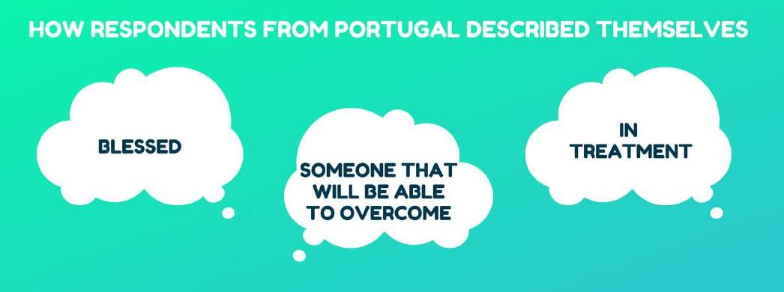
Future studies or surveys could look to expand on these areas. If we were able to reach a larger group of people more than three or even five years after diagnosis, it would be interesting to examine whether more people then think of themselves as ‘survivors’.

More information

Established in 2001, the GLCC comprises 40 non-government patient organisations from 29 nations: Argentina, Australia, Brazil, Bulgaria, Canada, Czech Republic, Denmark, Egypt, France, Germany, Ireland, Israel, Italy, Japan, Mexico, Netherlands, Norway, Peru, Portugal, Russia, Slovenia, South Africa, Spain, Sweden, Switzerland, Taiwan, Turkey, UK and USA.

The GLCC’s member from Portugal is Pulmonale. You can read more about their work here: http://www.pulmonale.pt/

The GLCC promotes global understanding of lung cancer and the right of patients to effective early detection, better treatment and supportive care. By serving as the international voice of lung cancer patients, the GLCC is committed to improving disease outcomes for all.

For more information about this study and the work of the GLCC please visit: www.lungcancercoalition.org or email our secretariat at: glcc@roycastle.org

