Understanding lung cancer patients’ experiences
Insights from the Global Lung Cancer Coalition’s 2023 global patient experience survey

Introduction

For the last four years, the Global Lung Cancer Coalition (GLCC) has run an annual global patient experience survey, gathering a wealth of useful data and insights on experiences of diagnosis, treatment, and care. We at the GLCC want to understand patients’ experiences of lung cancer and the barriers and challenges they face to inform our global and national campaigning priorities, and we conduct this survey yearly to ensure our ongoing activities and advocacy is reflective of current patient experiences, needs and preferences.

This report sets out the global findings from our fourth annual global survey, which ran from 22 February 2023 to 6 March 2023 and received 712 responses from patients across 14 countries.

We are grateful to all the patients who took the time to share their experiences via the survey. We hope the findings will be useful to policymakers in their planning, as well as to campaigners advocating for lung cancer patients’ needs.
Key Findings
The survey findings show that, whilst each patient’s experience during their lung cancer journey is different, there are some common themes in patient access and preferences across varying geographies and health systems:

- Whilst a majority of participants said they had undergone biomarker testing, nearly one-fifth were unaware if they had, suggesting that there may be significant gaps in patient information and communication about these tests. Of those who were tested, less than half (48%) knew what biomarker their cancer had, further underlining gaps in communication around testing, results, and their implications between patients and their treatment teams
- A substantial majority – 78% – of participants answered that they were aware of a lung health check or screening programme in their country, including participants in many countries that do not currently have any lung health check or screening programme widely available. The results of this question suggest that there is considerable confusion around these programmes – highlighting the need for further work to educate populations about the availability and process of screening programmes
- Almost one-fifth (18%) of participants stated that if invited to attend a lung health check or screening appointment, they would not have attended. This hesitancy may mirror issues in uptake across a range of different screening programmes, and suggests that further efforts to highlight the value of screening programmes should continue
- 91% of participants felt involved in decisions about their treatment and care when speaking to their treatment team, although only one-third of participants felt fully involved, suggesting that there is still work to be done – across all countries – to ensure patients feel informed and empowered to be involved in decisions around their treatment and care as much as they wish to be. Treatment teams should work to support lung cancer patients’ involvement in their care, whilst also recognising that patient preferences around involvement will differ
- Face-to-face meetings were the preferred method of conversation for participants in all situations, with the only exception being in situations when respondents were worried about something, when a preference for a conversation by telephone was the most common answer. Treatment teams should be ready to provide face-to-face meetings as a first option, whilst considering individual patient preferences as much as possible

As stated in our patient charter, the GLCC believes that every patient has the right to have access to quality health care; informed self-determination; physical and mental integrity; and confidentiality and privacy, and to be treated with dignity and respect. We are therefore calling on policymakers to ensure that policies implemented meet these standards.

A full breakdown of the responses can be found in the appendix.

Methodology

For the GLCC’s fourth annual patient experience survey, the steering group drafted questions on a range of topics, including:

- Diagnosis
- Testing and treatment
- Screening
- Involvement in decisions around treatment and care
- Seeking information

The Coalition commissioned Censuswide to conduct this global survey of lung cancer patients, with responding participants verified and enrolled to Censuswide’s network via direct recruitment. A series of 12 questions were included in the survey, with participants identified in each question by gender, age, and location.

The following countries were surveyed:

Argentina | Australia | Bulgaria | Canada
Denmark | Greece | Ireland | Israel
Italy | Portugal | South Africa | Spain
UK | USA

Demographics
Across the countries surveyed, 74% of respondents (524/712) were male, 26% of respondents (187/712) were female, and one respondent was non-binary.

Respondents most often answered that they were in the 45-54 age range, with 39% of respondents (280/512) in this range. The next most common age range was people over the age of 55, representing 27% of respondents (189/712), whilst only 22 respondents were in the 16-24 age range – the least common age range of respondents.

Deeper Dive

Diagnosis

Evidence indicates that diagnosing lung cancer earlier, when there is a higher chance of treatment being successful, will reduce the burden currently imposed on the individuals affected, their families, and the healthcare system as a whole, and improve survival rates. To this end, we wanted to understand the type of lung cancer participants were diagnosed with and how old they were at the time.

Key Findings
The 45-49 age range was the most common age at diagnosis, and non-small cell lung cancer was the most common diagnosis amongst respondents.

A majority of participants had been diagnosed with non-small cell lung cancer (62%, 440/712), and nearly one-third of participants (31%, 222/712) had been diagnosed with lung cancer between the ages of 45-49. This was the most common age range at diagnosis, with age 15-39 as the next most common answer (27%, 190/712).

Testing and Treatment

Advances in testing and treatment, particularly in precision medicine, have provided new opportunities for treatment teams to provide better tailored treatment and care to individual patients and the type of cancer they have. We wanted to understand if participants had been able to undergo biomarker testing, and if they knew what biomarker their cancer has as a result. Participants who had, or were currently receiving treatment, were also asked what treatments they had received.

Key Findings
A portion of respondents were unsure if they had undergone biomarker testing, and of the small group who had not had testing, a vast majority would have liked to. Furthermore, of participants who had been tested, less than half knew what biomarker their cancer had – suggesting that there is a notable gap between access to testing and information around testing and may highlight a lack of communication between treatment teams and patients.

We found that a majority of participants (53%, 377/712) were currently undergoing treatment when answering the survey, and over one-third of the remaining participants (37%, 264/712) had finished treatment. A large majority (68%, 484/712) of participants answered that they had undergone biomarker testing, with a substantial portion (19%, 134/712) of respondents answering that they were unsure if they had undergone biomarker testing. A smaller group (13%, 94/712) answered that they had not had testing, almost three-quarters (73%, 69/94) of whom answered that they did not have biomarker testing but would have liked to. When participants who had received biomarker testing were asked if they knew what biomarker their cancer had, just below half of respondents (48%, 234/484) said that they did, while almost one-third of participants (32%, 156/484) answering that they were waiting for their test results.

When asked about treatments received, almost half of participants (47%, 304/641) answered that they had received chemotherapy, with over one-third (35%, 222/641) answering that they had undergone radiotherapy. Less than one-third of participants answered that they had been treated with targeted therapies (29%, 184/641), with a similar number of participants (30%, 195/641) answering that they had been treated in a clinical trial.

Screening

In a small number of countries, there are national programmes that invite people who may be at a higher risk of lung cancer to have a lung screening appointment or health check. We wanted to understand if patients were aware of screening programmes and if they had been invited and/or diagnosed through these programmes. Additionally, we wanted to understand if they would attend a screening appointment if a national programme was available in their country and they were invited.

Key Findings
Over three-quarters of participants answered that they were aware of a lung health check, screening programme, or lung screening in their country. As we know that many of the surveyed countries do not have these programmes, the findings suggest that there is substantial confusion around screening programmes, including what they are and where they are available.

When asked if they were aware of a lung health check, screening programme, or lung screening in their country, over three-quarters (78%, 555/712) of participants responded yes, with less than ten percent (7%, 50/712) answering that they were not sure. A large majority (82%, 454/555) of those who were aware of a lung health check or screening programme answered that they had been invited to an appointment, and fifteen percent (15%, 81/555) of participants answering the same question stated that they had not been invited for an appointment.

Almost three-quarters (72%, 329/454) of participants who had been invited to a lung health check or screening answered that they attended a screening appointment and were diagnosed with lung cancer as a result. Over one quarter (26%, 118/454) of respondents to the same question answered that they had attended a screening appointment but had been diagnosed with lung cancer through another route. A very small number of participants (2%, 7/454) answered that they had been invited to attend a lung health check or screening but had chosen not to attend.

When asked, three-quarters of participants (75%, 534/712) stated that they would attend a lung cancer screening or health check if they had been invited. However, almost twenty percent (18%, 131/712) said they would not attend a screening appointment if they had been invited.

Involvement in decisions around treatment and care

The GLCC believes that every patient has the right to be fully informed of, and be involved in, decisions about their treatment and care. This right is enshrined in the GLCC’s Patient Charter. We wanted to understand the extent to which lung cancer patients feel involved in decisions made about their treatment and care, and the methods by which they preferred to communicate with their treatment team in various situations.

Key Findings
A vast majority of participants felt involved in decisions about their treatment and care, and most participants preferred face-to-face meetings in almost all situations – highlighting that despite changes in the availability of tele-health, patient preferences can vary, and treatment teams should take care to accommodate these preferences.

A vast majority (91%, 647/712) of participants answered that they did feel involved in decisions about their treatment and care when talking to their treatment team. Within this group, just over one-third (34%, 245/647) answered that they had been fully involved, with a larger group (43%, 303/647) answering that they had been mostly involved, and a small group (14%, 99/647) answering that they had been involved sometimes.

Of the small group (9%, 65/712) of participants who answered that they did not feel involved in decisions about their treatment and care, one-third (3%, 22/65) stated that they would have liked to have been involved.

When asked about preferences around meeting with their treatment teams in different situations, face-to-face meetings were most participants preferred method of conversation in almost all situations; almost half (48%, 340/712) of participants answered that they would prefer face-to-face meetings when finding out their diagnosis and over half (56%, 401/712) of participants answered the same with respect to regular check-ups. The only exception to a plurality of participants preferring face-to-face meetings was in a situation when participants were worried about something, with a slightly greater number (38%, 273/712) of participants preferring to contact their team by telephone, compared with those (37%, 262/712) who said they would wish to have face-to-face contact in this situation.

Seeking information

The GLCC believes that lung cancer patients should receive high-quality information, which tells patients what they want to know, at the right time for them. We wanted to understand the ways if participants felt they had received the information they needed at the right time.

Key Findings
A substantial portion of participants felt that the information they received came too late, suggesting that more work needs to be done to ensure patients are informed as much as they prefer, at a time that is right for them.

Over half of participants (58%, 412/712) responded that they got the information they needed at the right time, while another quarter (24%, 173/712) of participants felt that the information came too late. Almost ten percent (9%, 66/712) of participants stated that they did not want information, and a small number (3%, 22/712) of participants felt that they had to look for information on their own.

More information

The Global Lung Cancer Coalition is an alliance of patient organisations from across the world. Established in 2001, the GLCC comprises 42 non-government patient organisations from 30 nations: Argentina, Australia, Brazil, Bulgaria, Canada, Czech Republic, Denmark, Egypt, France, Germany, Greece, Ireland, Israel, Italy, Japan, Mexico, Netherlands, Norway, Peru, Portugal, Russia, Slovenia, South Africa, Spain, Sweden, Switzerland, Taiwan, Turkey, UK, and USA.

The GLCC promotes global understanding of lung cancer and the right of patients to effective early detection, better treatment, and supportive care. By serving as the international voice of lung cancer patients, the GLCC is committed to improving disease outcomes for all.

For more information about our 2023 survey, the findings from previous global patient experience surveys, or the work of the GLCC, please visit our website at www.lungcancercoalition.org or email our secretariat at: glcc@roycastle.org.

Appendix – data tables

Q1. What type of lung cancer were you diagnosed with?

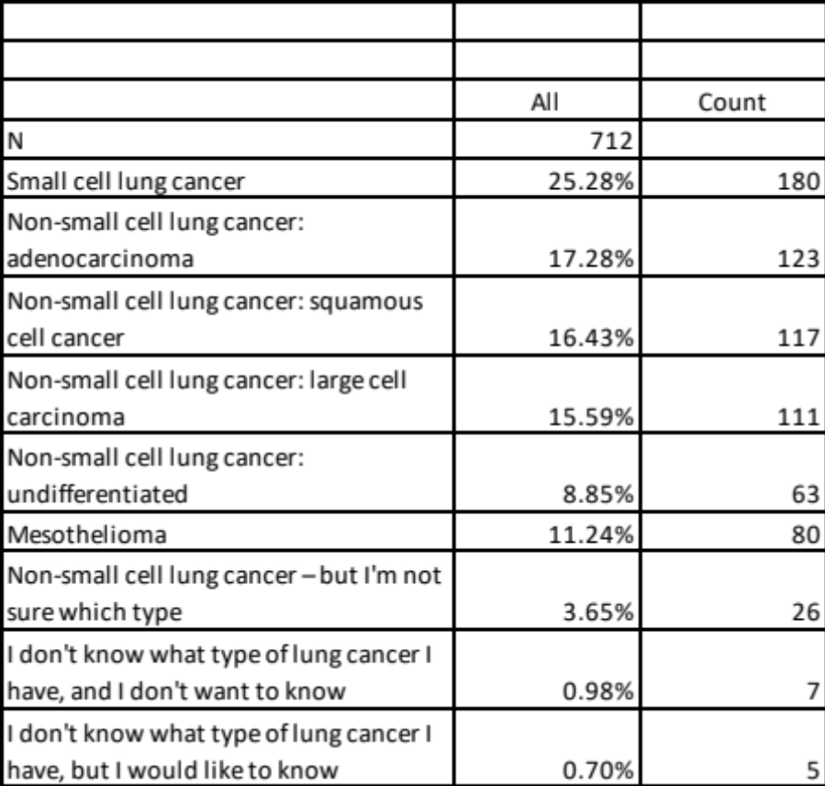

Q2. When were you diagnosed with lung cancer?

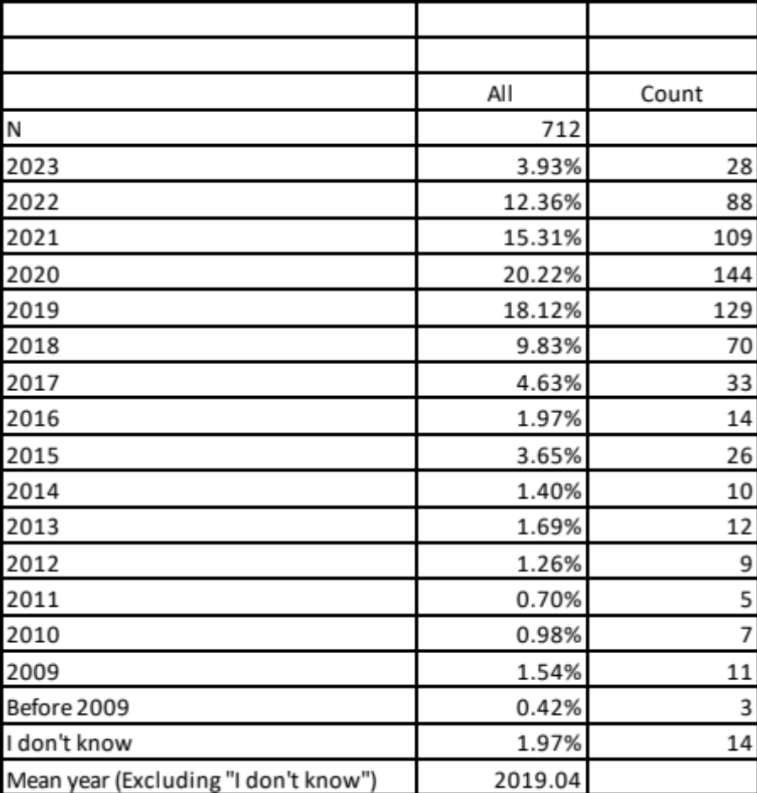

Q3. How old were you when you were diagnosed with lung cancer?

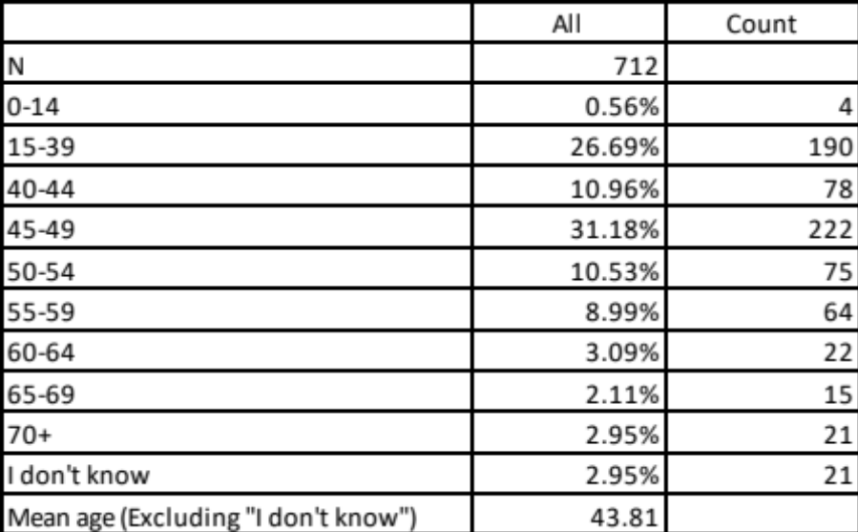

Q4. Which of the following best describes you?

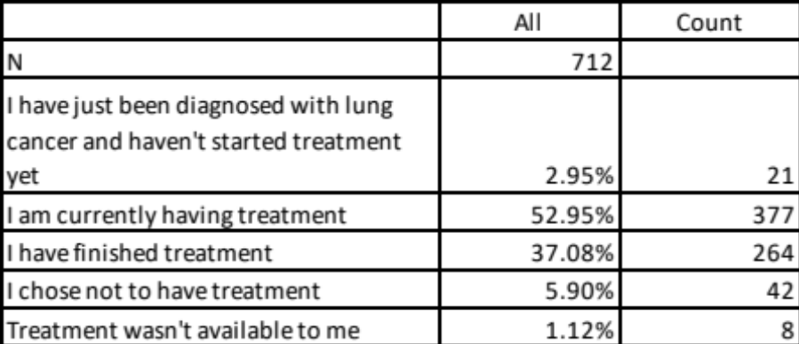

Q5. Doctors can take a sample of a tumour to test for biomarkers (also known as mutation, genomic, or molecular testing). This helps the treatment team decide which treatment to give. Did you have any biomarker testing?

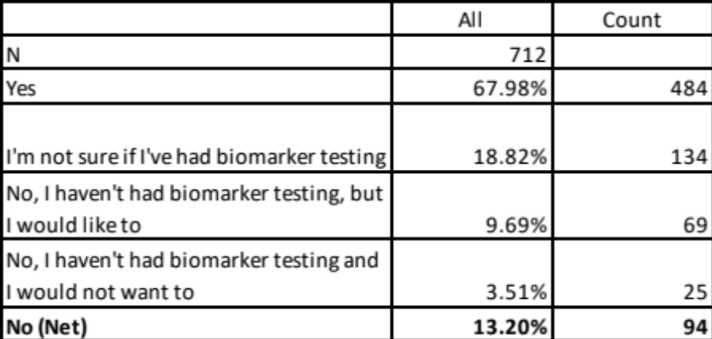

Q5a. Which of the following best describes the results? (Select best match)
*Those who had biomarker testing

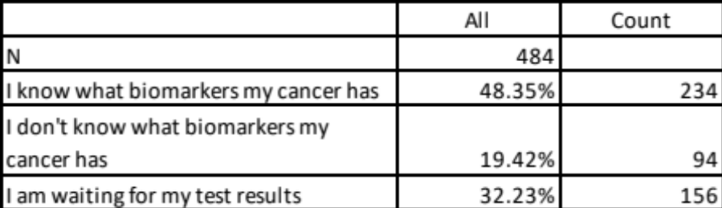

Q6. Which types of treatment have you received? Please tick all that apply
*Those who have had treatment or are currently receiving treatment

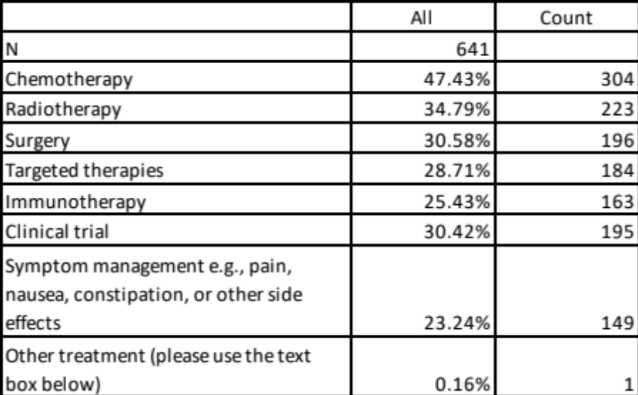

Q7. In some countries there are national programmes which invite groups of people who may be at higher risk of lung cancer to have a lung screening appointment or lung health check. Are you aware of a lung health check, screening programme, or lung screening in your country?

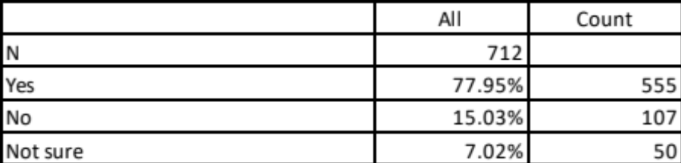

Q8. Have you been invited to a lung health check or screening appointment?
*Those who are aware of a lung health check/ screening programme

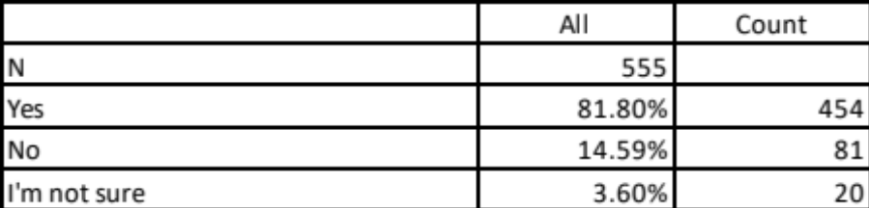

Q8a. Which of the following best describes the results of the lung health check or screening appointment? (Select best match)
*Those who have been invited to a lung health check/ screening programme

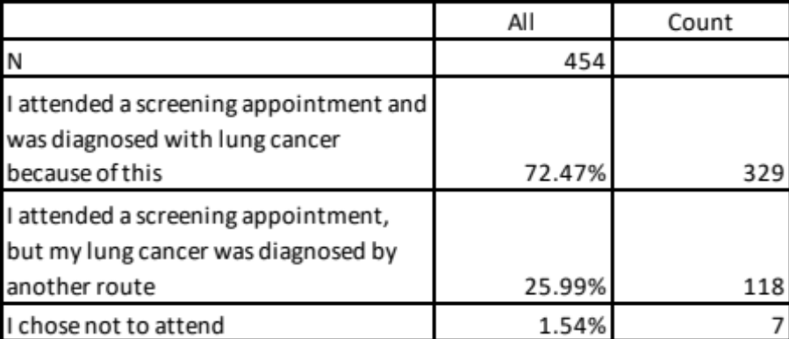

Q9. If you had been invited to attend a lung health check or screening appointment before your diagnosis, would you have attended?

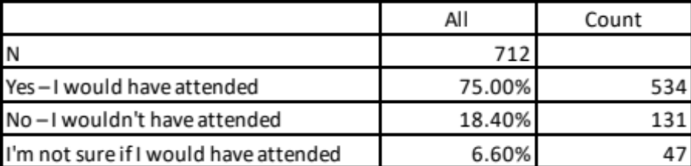

Q10. When talking to your treatment team, did you feel involved in the decisions about your treatment and care? Please choose the option that best describes you.

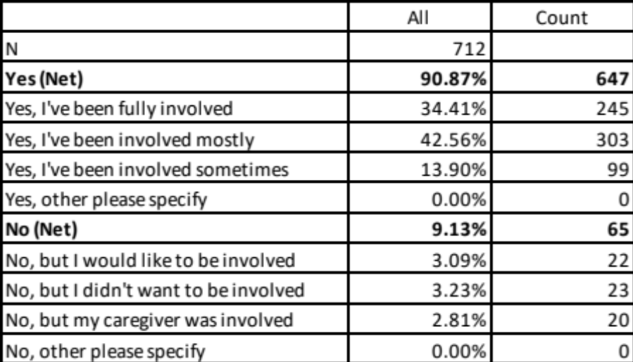

Q11. What do you think is the best way to have a conversation with your treatment team in the following situations?
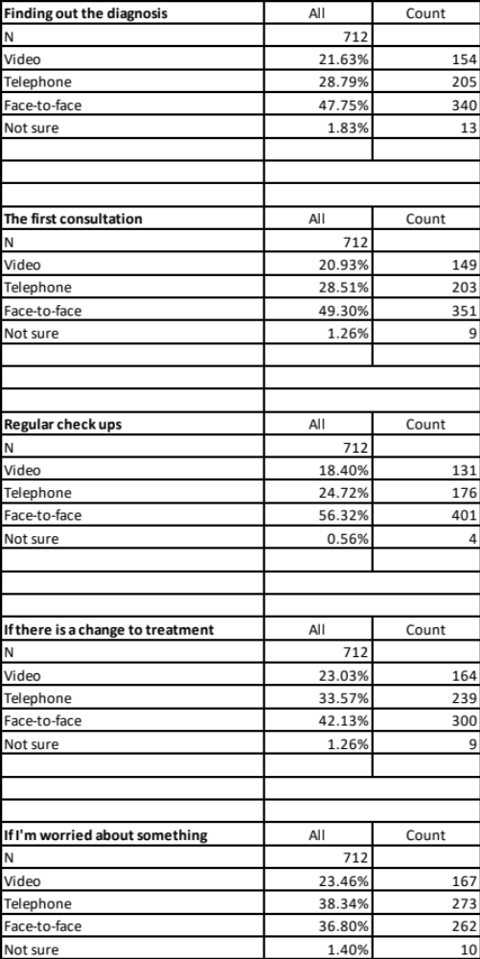
Q12a. The GLCC believes that lung cancer patients should receive high quality information, which tells you what you want to know and at the right time for you. What best describes how you feel about the information you received from your treatment team about your lung cancer? Please choose the option that best describes you.

