Understanding lung cancer patients’ experiences
Insights from the Global Lung Cancer Coalition’s 2025 global patient experience survey
September 2025

Introduction

For the last six years, the Global Lung Cancer Coalition (GLCC) has run an annual global patient experience survey, gathering a wealth of useful data and insights on experiences of diagnosis, treatment, and care. The findings from this survey shine a light on the needs and preferences of patients, informing GLCC’s global activity and members’ campaigning priorities. The GLCC additionally hope the findings will be useful to policymakers in their planning, as well as to campaigners advocating for lung cancer patients’ needs around the world.

This report sets out the global findings from the 2025 global survey, which ran from 02 May 2025 to 12 May 2025 and received 900 responses from patients across 18 countries.

The GLCC is grateful to all the patients who took the time to share their experiences via the survey.
Key findings & common themes

As stated in our patient charter, the GLCC believes that every patient has the right to have access to quality health care; informed self-determination; physical and mental integrity; confidentiality and privacy, and to be treated with dignity and respect.

Whilst each patient’s experience and preferences during their lung cancer journey differ, some common themes emerge across different geographies and health systems.

This year’s patient experience survey highlighted some encouraging trends including patients feeling involved in their treatment and care, the majority receiving information at appropriate times, and support generally matching patients’ needs.

However, the survey’s results also showcase key areas for improvement. There is a clear need to strengthen communication to patients around key aspects of care – especially regarding diagnostic testing and the implications of different results. Additionally, treatment and support teams should be encouraged and supported to accommodate patient preferences throughout all aspects of care.

Methodology

This survey included questions on the following topics:

- Involvement in treatment and care
- Reflections on information and communication
- Help to cope
- Experiences of palliative care
- Biomarker testing

As in previous years, the Coalition commissioned Censuswide to conduct this global survey of lung cancer patients, with responding participants verified and enrolled to Censuswide’s network via direct recruitment. 13 questions were included in the survey, with participants identified in each question by gender, age, and location.

The following countries were surveyed:

Argentina, Australia, Brazil, Canada, Greece, Hong Kong, Hungary, Ireland, Israel, Italy, Japan, Mexico, Portugal, South Africa, Spain, Taiwan, UK, USA

Demographics

Across the countries surveyed, 52% of respondents (472/900) were male and 48% were female (428/900).

50% of respondents were 65+ years old (448/900). A full breakdown of ages is included below:

- Under 30: 29
- 30-34: 26
- 35-39: 20
- 40-44: 29
- 45-49: 21
- 50-54: 9
- 55-59: 21
- 60-64: 297
- 65-69: 315
- 70-74: 96
- 75-79: 26
- 80-84: 6
- Over 85: 5

Respondents provided information about their diagnosis, including when they were diagnosed, their age at diagnosis, and whether they are currently receiving treatment:

- 86% (778/900) had been diagnosed in the last five years
- 62% (554/900) were between 60-69 when diagnosed
- 57% (510/900) are currently receiving treatment

Deeper Dive

Patients’ Involvement in their Treatment and Care

The GLCC’s Patient Charter reaffirms the right of every patient to be fully informed of, and involved in, decisions about their treatment and care.

As such, this survey sought to explore the extent to which lung cancer patients
feel involved in decisions made about their treatment and care, and the methods by which
they prefer to communicate with their treatment team in various situations.

Respondents were asked the following regarding their treatment and care:
- When talking to your treatment and support team, did you feel involved in the decisions about your treatment and care?

- What do you think is the best way to have a conversation with your treatment and support team in the following situations: (a) finding out the diagnosis, (b) the first consultation, (c) regular check-ups, (d) if there is a change to treatment, (e) if there is a change in my disease, (f) if I am worried about something)?

As per Figure 1, 98% (880/900) of respondents felt involved in decisions about their treatment and care, and over half of respondents (58% 518/900) answered that they had been fully involved. This represents a notable improvement from 2024, when 48% reported being fully involved, reflecting a 10-percentage point increase in 2025.

However, nearly one third (32%, 289/900) said they would have liked to have been more involved in decisions about their care. As in previous years, a very small percentage (0.2%, 2/900) noted they did not want to be involved, underscoring the importance of speaking with patients to understand their preferences.

When asked about preferences around meeting with their treatment and support teams, throughout the care pathway most participants preferred face-to-face meetings in all situations but one, as shown in Figure 2. When patients were worried about something, respondents slightly preferred telephone calls to face-to-face (39% vs. 36%). While patients were not asked directly why they preferred telephone calls in this instance, it might reflect ease and/or speed of access in different countries.

Key insight: It is crucial that healthcare professionals strive to ensure patients are as involved in their treatment and care as they would like to be. While it is encouraging that a large proportion of respondents feel fully involved in their treatment and care, the findings suggest more can be done to achieve this for everyone.

While face-to-face interaction remains the preferred mode of communication throughout most of the care pathway, patients tend to favour telephone contact when they are worried, suggesting they prioritise immediate access and emotional reassurance over in-person consultations in these situations. These preferences highlight the need for flexible, patient-centred communication strategies, particularly as telehealth options increase.

Seeking information

In addition to conversations with their treatment and support teams, the GLCC sought to better understand patients’ views on the information they receive. Respondents were asked:

- To accompany the discussions with your treatment and support team, what is your preferred format for receiving information about your condition, if any?

- What best describes how you feel about the information you received from your treatment and support team about your lung cancer?

- To note: For this question, patients were asked how they felt about the information they received at different stages of the care pathway including: (a) at diagnosis, (b) when starting treatment, (c) when changing treatment, (d) when ending treatment / follow-up, (e) when accessing palliative care

Preferences for information format varied, with print materials (20%, 182/900), cancer support helplines (19%, 174/900), and videos (13%, 118/900) all ranking highly (as seen in Figure 3). This has remained broadly similar to the 2024 findings, where both print materias and cancer helplines were ranked highlight (29%, 261/905) and (33%, 297/905) respectively.

Differences were particularly noticeable across countries, likely reflecting differences in culture, healthcare systems and the availability of patient support services. Table 1 sets out the most popular formats for receiving information across each of the 18 countries.
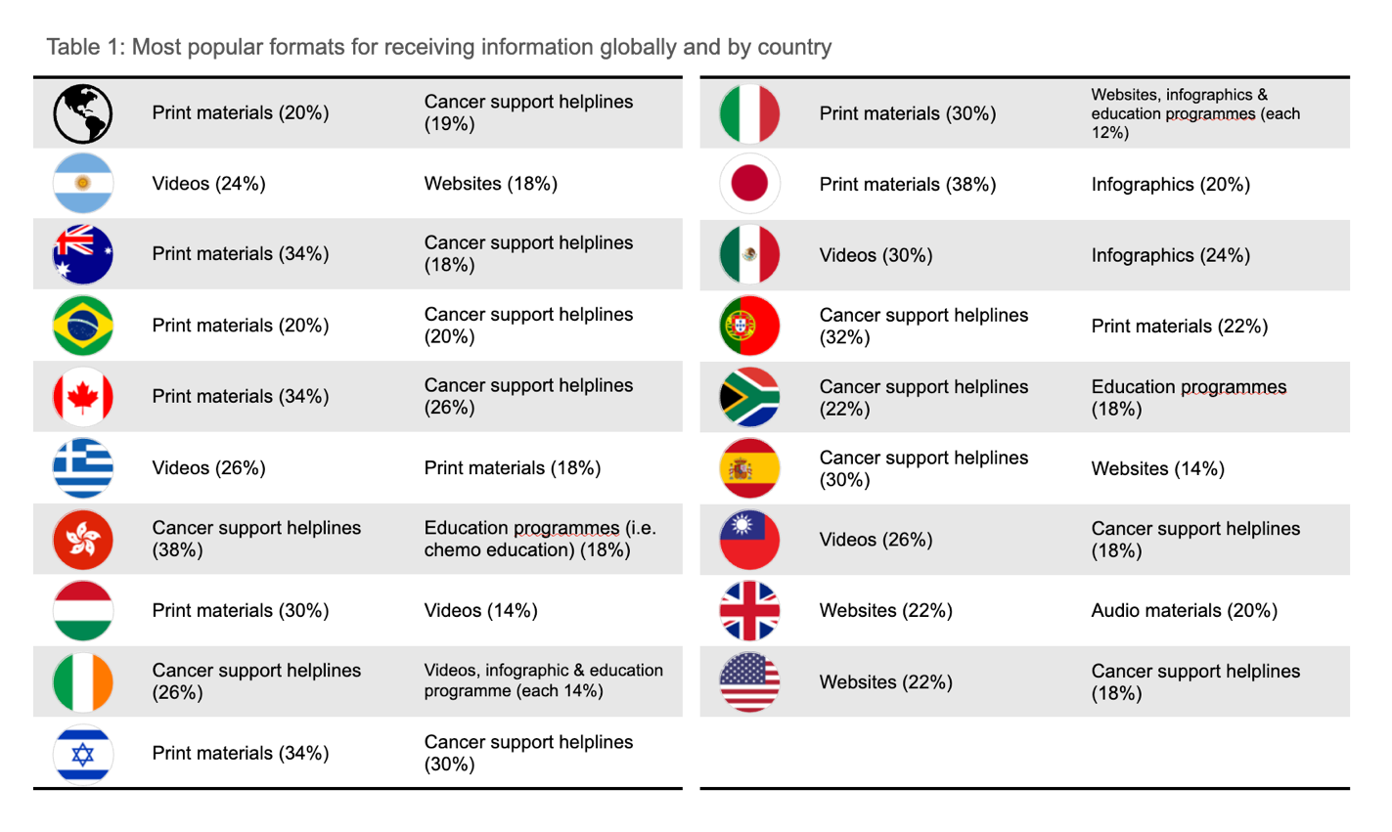

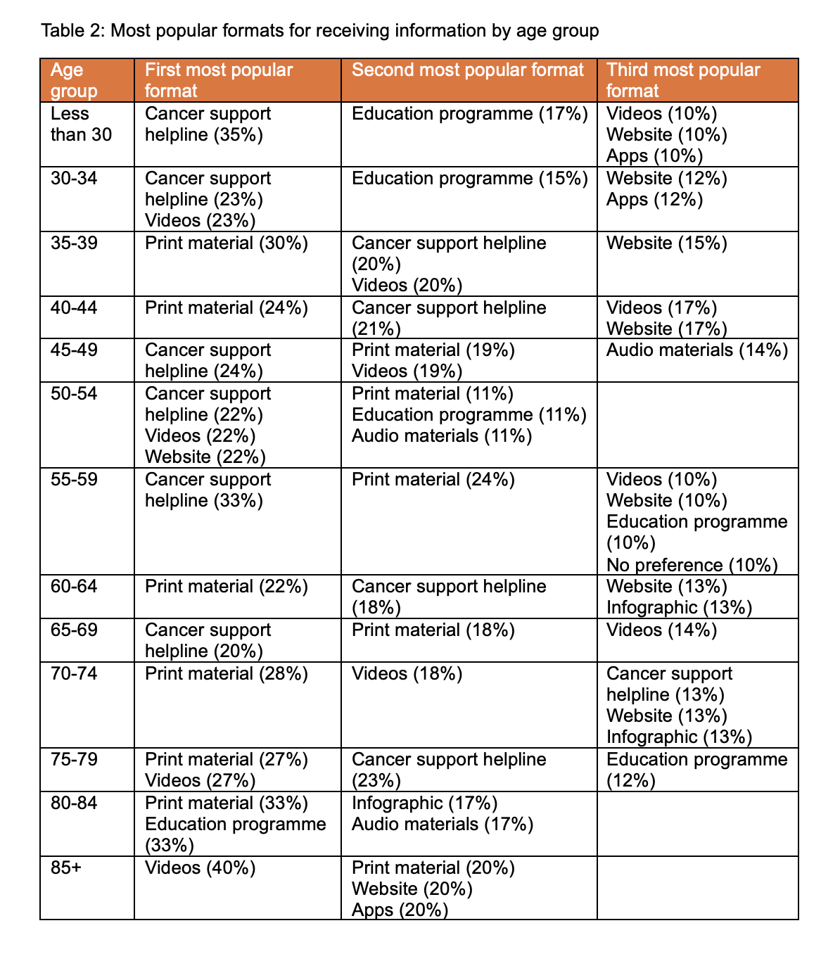
Although less stark than differences across countries, the survey responses also showed variation in preferred formats for receiving information across different age groups. Younger respondents (under 35) most commonly prefer using a cancer support helpline or receiving information through videos, reflecting a tendency toward interactive and voice-based formats. Among older adults (60+), print material became increasingly popular, particularly in the 70-84 age range. This suggests a shift in preference toward more traditional formats in older populations. Table 2 sets out the most popular formats for receiving information across all countries, broken down by age groups.

As well as being asked about their preferred format to receive information, patients were asked about how they felt about the usefulness of and timing in which they received the information across care pathways.

An average of 61% (530/866) of respondents said they received the right information at the right time (Table 3), a significant decline from 77% in 2024. Across the care pathway, 9% (81/866) of respondents reported the information received was not helpful, 10% (86/866) said it came too late and 3% (25/866) noted it was both unhelpful and came too late. This issue was particularly evident at the point of diagnosis and when changing treatment where 24% (215/900) and 23% (192/844) of respondents respectively noted it came too late, was unhelpful, or both.

These are critical stages in the care pathway, where important decisions about
treatment and care are made. To enable them to participate in shared decision-making, it is therefore essential that patients feel fully informed and supported at these stages.
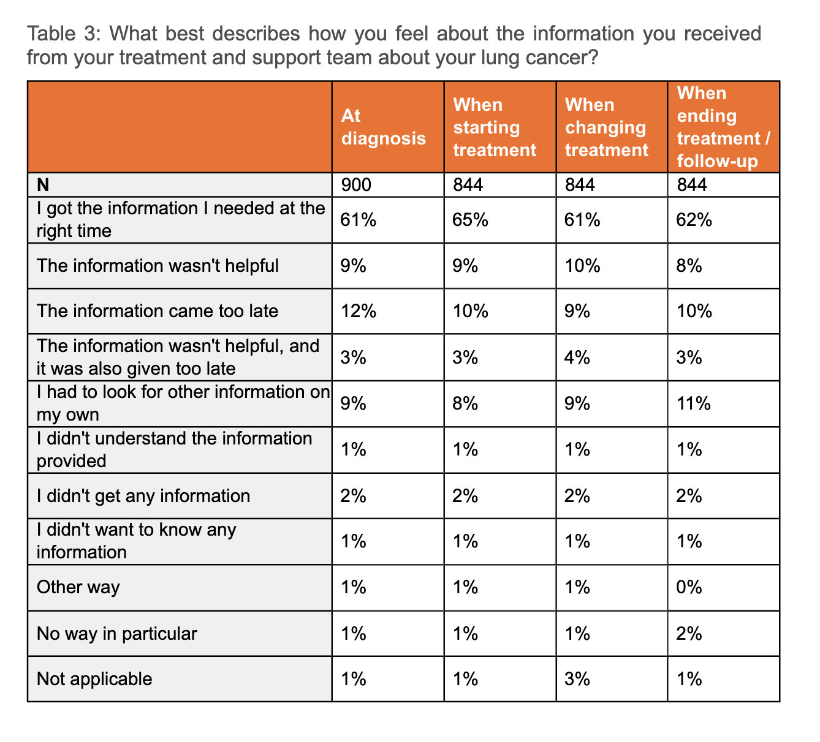

Key insight: Ensuring patients receive the right information at the right time remains a critical unmet need. More needs to be done to ensure that at key moments in the care pathway, communication is not only prompt but also relevant, understandable, and tailored to individual needs.

As part of this, patient preferences for information formats should be considered and reflected in the use of personalised, multi-channel approaches.

Help to Cope

Respondents were asked about the support they receive to help them cope with their disease, including:

- Where do you get help to cope with your disease, if anywhere?

- Where would you like to get help to cope with your disease, if anywhere?

- What is the most important help you need at the moment?

As shown in Figure 4, patients reported receiving support from a variety of sources. The most common included healthcare professionals 30% (273/900), helplines/chats/text services for support, information and referral 23% (209/900), family and friends 22% (206/900) and counselling or therapy 21% (189/900). Compared with 2024, when healthcare professionals (67%) and family and friends (62%) were by far the most common sources of support, the 2025 results suggest a decline in reliance on these traditional sources and a shift towards more diverse forms of support, including helplines and counselling.

Respondents were also asked what support they would like to receive. Encouragingly, as seen in Figure 4, the desired sources of support generally aligned with those already being accessed, suggesting that many patients are getting the kind of help they want.

However, there were some clear gaps and variations across countries, highlighting areas where support could be improved. For example:

- In the UK while only 14% (7/50) of respondents indicated they currently receive support from healthcare professionals, 30% (15/50) would like to
- In Argentina, 14% (7/50) access counselling or therapy, but 22% (11/50) would prefer to receive support this way
- In Hong Kong, only 8% (4/50) currently access education programmes, compared to 18% (9/50) who would like to
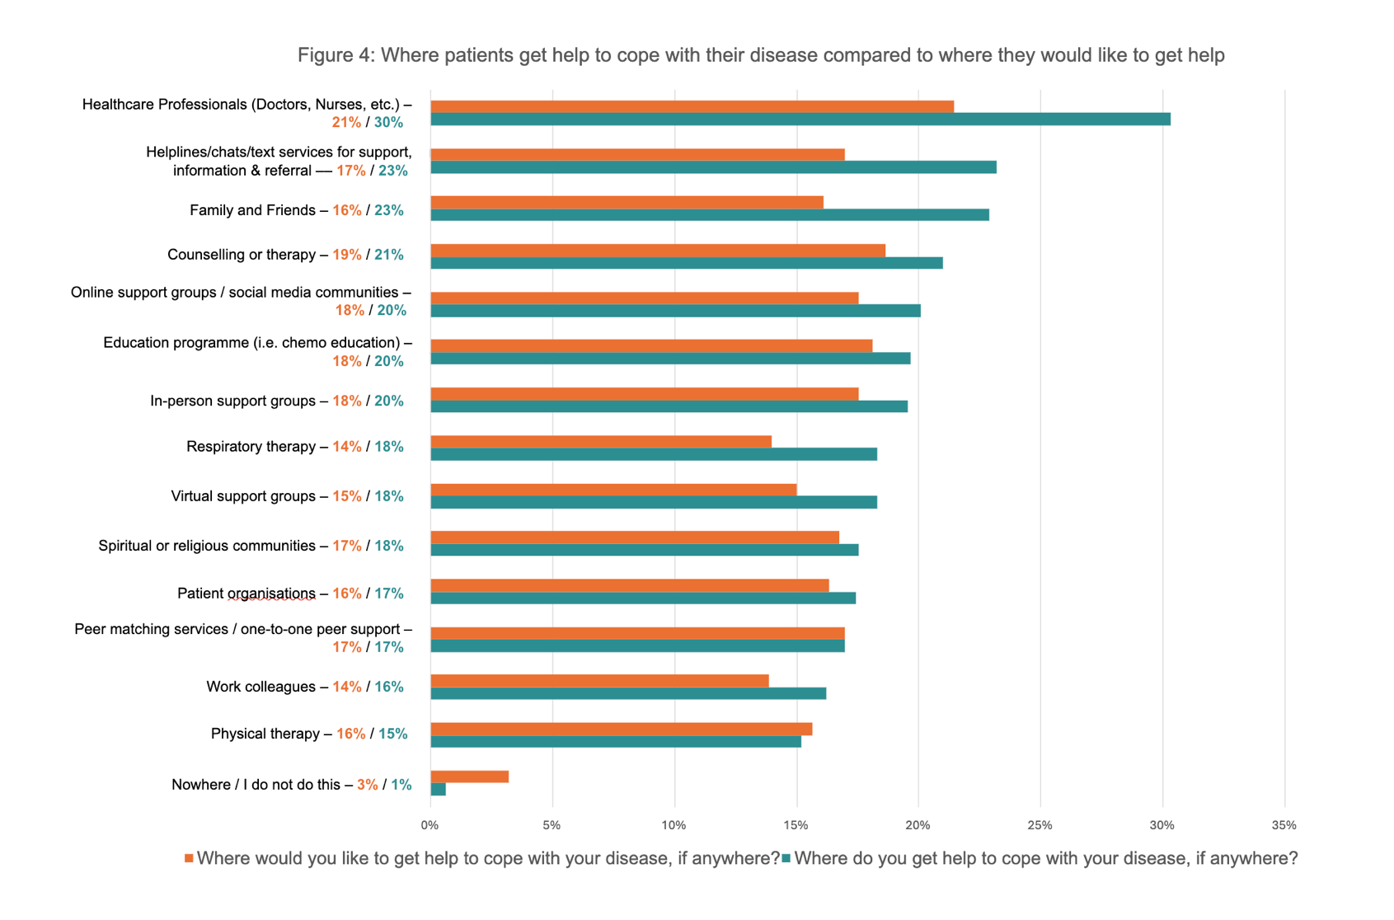

Respondents were also asked to rank the help they need most at the moment. Emotional support (such as counselling, mental health services or someone to talk to), medical care (including better access to doctors, treatments or pain management), and financial assistance (help with covering medical costs, travel expenses or daily living costs) were ranked the highest by most respondents.

As seen in Table 4, there was notable variation in preferences across countries compared to the global average, highlighting the value of examining country-specific insights to better understand and address local patient needs.

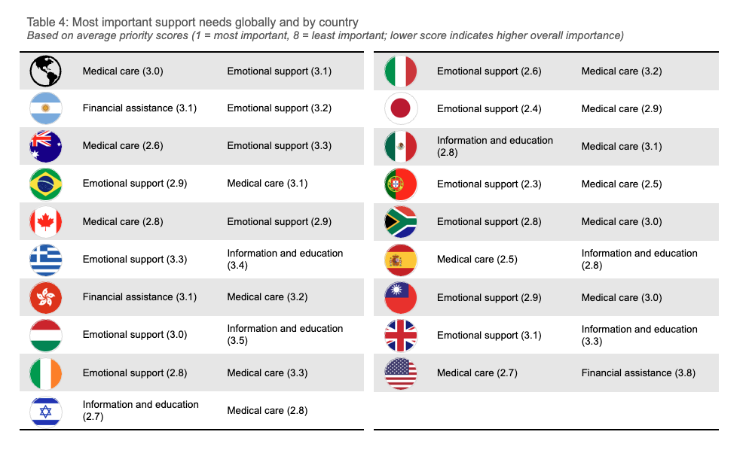

Key insight: Lung cancer patients require medical care, emotional support, and clear information, but their priorities can vary by country due to differences in culture, health systems, and available support. While existing support largely aligns with patients’ needs, opportunities remain to better tailor services in some countries to close the gap between the support received and what patients find most helpful. Thus, developing, evaluating and refining locally responsive, holistic care models that go beyond clinical treatment is essential.

Further insights

This year’s survey has highlighted some challenging results in relation to questions on biomarker testing and palliative care. It is possible that some of these findings have been influenced by misunderstandings among respondents around questions and the terminology used. Given these misunderstandings, the results of the following questions are likely skewed and may not fully reflect the patient experience. Nonetheless, they highlight an important opportunity to improve communication to patients around these key aspects of their treatment and care.

Lung Cancer Type & Biomarker Testing

When asked about their lung cancer type, a significantly larger number of respondents than expected selected multiple cancer types. Although medically possible, this did not match the expected real-world distribution.

As biomarker testing is only relevant to this specific type of lung cancer, only respondents who identified as having non-small cell lung cancer were asked follow-up questions on this topic. However, given the confusion around lung cancer types, it is likely that some respondents were misclassified, making the biomarker testing results unreliable. This uncertainty led to the decision to omit these findings from the report.

While this presented a challenge for the survey results, it also points to a potentially important gap that many patients may not fully understand or be aware of their lung cancer type. This highlights the need for clearer communication and better patient education to ensure individuals are informed about their diagnosis and the tests or treatments relevant to their care.

Palliative Care

Following on from confusion in the 2024 survey around the meaning of palliative care, this year’s survey included the following definition:

Throughout the survey the GLCC include the phrase ‘palliative care.’ However, the GLCC appreciate in different countries and cultures this care may be referred to by different names. For this survey, ‘palliative care’ refers specialised care providing physical, emotional and spiritual support for patients living with chronic conditions or serious illness. Palliative care helps patients manage both physical symptoms and emotional stressors and focuses on patient’s goals for care. It can be provided alongside other treatments patients might be receiving.

However, where palliative care was included in the survey (either in specific questions or as part of the care pathway), there was a very large variation in responses, suggesting confusion or varying interpretations of what was meant by ‘palliative care’.

Overall, these inconsistencies make it difficult to draw reliable conclusions about patients’ palliative care experiences and highlight the need for clearer communication with patients about its role in lung cancer care.

Conclusion

This year’s survey findings are encouraging, showing that many lung cancer patients feel involved in their care, receive timely and relevant information, and have their support needs met. However, there is still room for improvement. Communication around diagnostic testing and its implications must be strengthened, and treatment and support teams should be supported to better accommodate patient preferences throughout the care journey.

Patients value personalised, timely communication, especially at critical moments. As telehealth grows, flexible, multi-channel strategies that align with individual needs are increasingly important. Differences across countries also highlight the need for locally responsive, culturally sensitive care that extends beyond clinical treatment and includes emotional and informational support.

The GLCC is calling on governments and health systems worldwide to support healthcare professionals to:

- Deliver clear, timely, and relevant information at key moments in the care journey
- Strengthen communication to patients about diagnostic testing and the implications of different results for patients
- Accommodate patient preference in all aspects of treatment and care

More information

The Global Lung Cancer Coalition is an alliance of patient organisations from across the world. Established in 2001, the GLCC comprises 44 non-government organisations from 32 nations/territories: Argentina, Australia, Brazil, Bulgaria, Canada, Czech Republic, Denmark, France, Germany, Greece, Hong Kong, Hungary, India, Ireland, Israel, Italy, Japan, Mexico, Netherlands, Norway, Peru, Portugal, Slovenia, South Africa, Spain, Sweden, Switzerland, Taiwan, Thailand, Turkey, UK and USA.

The GLCC promotes global understanding of lung cancer and the right of patients to effective early detection, better treatment, and supportive care. By serving as the international voice of lung cancer patients, the GLCC is committed to improving disease outcomes for all.

For more information about our 2025 survey, the findings from previous global patient experience surveys, or the work of the GLCC, please visit our website at https://www.lungcancercoalition.org or email our secretariat at: glcc@roycastle.org.

